Web Engineering

Lab # 04

Cascading Style Sheet

Objectives

* 1. Styling the HTML document using CSS
  2. Task1 .Write code for following layout using table and universal selector

Hint:

1. <style>*{ color: <colour of your own choice>} </style>
2. <table border="2" width="800">

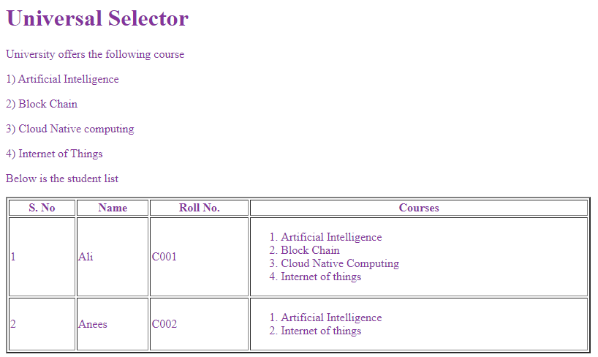

Task 2 Using the **type selector** apply different colours to table headings and list items on above layout

Hint:

<style>

th { color: <color1>

}

li { color: <color2>

}

</style>

Task 3

CLASS SELECTOR

Implement the class selector to produce the following output.

|  |  |
| --- | --- |
| Hint  <style>  .aic {color: darksalmon;}  .bcc,  .iot {color: royalblue;}  p.cnc {color: goldenrod; }  </style>  <p class="aic" )>  Artificial Intelligence  </p> |  |

Task 4 ID SELECTOR

Style above page heading and text “University offers following course” using ID selector.

Hint <style> #heading { color: <anycolor> }

#para….{ color: <anycolor> } </style>

<h1 id="heading">ID Selector</h1>

Task 5 CHILD SELECTOR

Change the colour of Paragraph with Parent div

Hint: div > p { color: <anycolor> } and

Ol>li> p { color: <anycolor> }

Task 6 DESCENT SELECTOR

Change the colour of Paragraph <p> with table row <tr> Parent

Hint

tr p { color: darksalmon; }

Task 7 ADJASCENT SIBLING

Change the colour of text “University offers following courses”

Hint h1+p

Task 8 GENERAL SIBLING

Change the colour of all sibling of <p> “University offers following courses”

Hint h1~p

Task 9 CASCADING RULE

If we apply more than one rule to same element which will be priorities. Last rule will be applied.

Test above rule using css. Try following code and discuss the result

i { color: darksalmon; }

i { color: royalblue; }

b { color: orange; }

p b { color: turquoise !important; }

p b { color: pink; }

</style>

<body>

<h1 id="heading"> CSS rules</h1>

<p id="sentence"> The Girls socity of the <i> Univeristy Computer science department

</i> is committed to empower and autonomy of the women in Pakistan

</p>

<p>

Girls in techonolgy <i> WIT</i> is a <b> group </b> dedicated for girls

</p>

<div> Women currently make up for only <b> 30% of the student body</b> at CS </div>

</body>

</html>

Task 10 Inheritance

Try the following code with and without inheritance word in style. Share your observation

<!DOCTYPE html>

<html lang="en">

<head>

<title>CSS Inheritence</title>

</head>

<style>

body {

color: lightcoral;

padding: 20px;

}

p {

padding: inherit

}

div {

color: mediumturquoise;

}

a {

color: inherit

}

</style>

<body>

<h1> CSS Inheritence</h1>

<p> The Girls socity of the <i> Univeristy Computer science department

</i> is committed to empower and autonomy of the women in Pakistan

</p>

<p>

Girls in techonolgy <i> WIT</i> is a <b> group </b> dedicated for girls

</p>

<div> Women currently make up for only <b> 30% of the student body</b> at CS. visit <a href="#index"> PWIC</a>

</div>

</body>

</html>

Task 11 Background Color

Write code for following webpage, you can use any colours, heading and text

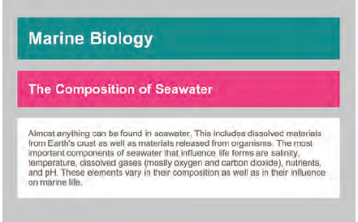

Task 12 Opacity

Applied following opacity in your webpage.

Hint: .mainDiv {

display: inline-block;

width: 200px;

text-align: center;

height: 200px;

}

.div1 {

background-color: rgb(0, 255, 0);

padding: 50px;

opacity: 1;

}

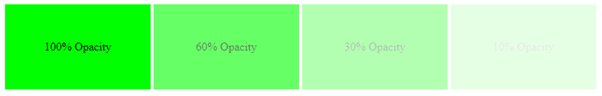

Task 13 Opacity

Apply opacity using RGBA(0,255,0,.6) and discuss the results

Task 14

Write simple program for HSL and HSLA